Java String:

String s="javatpoint";

char[] ch={'j','a','v','a','t','p','o','i','n','t'};

String s=new String(ch);

Two ways to create String object:

1.By string literal

2.By new keyword

By string literal:

More memory efficient

String s1="Welcome";

String s2="Welcome";//It doesn't create a new instance Its Links Existing instance

String Program Examples:

public class StringExample{

public static void main(String args[]){

String s1="java";//creating string by java string literal

char ch[]={'s','t','r','i','n','g','s'};

String s2=new String(ch);//converting char array to string

String s3=new String("example");//creating java string by new keyword

System.out.println(s1);

System.out.println(s2);

System.out.println(s3);

}}

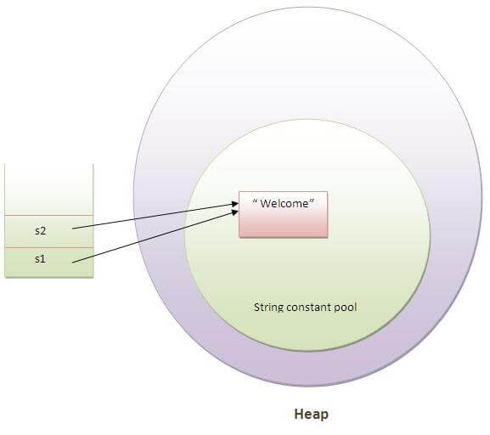

For Examples

String s1 =”mark”;

String s2 =”mark”;

String s2 =”s1.concat(“ravi”);

mark object created in pool memory

It doesn't create a new instance Its Links Existing instance

S2 will be orphaned “Second Line”

It will goes to garbage collection

String:

Immutable - It doesn't create a new instance Its Links Existing instance

Syncronization

String Buffer:

Mutable - Override Existing instance

Syncronization

String Builder:

Mutable - Override Existing instance

Non-Syncronization

String Methods:

Commonly We Use 14 String Method

String s1 = "welcome";

String s6 = "welcomE";

String s2 = " welcome";

System.out.println(s1.length());

System.out.println(s1.trim());

System.out.println(s1.indexOf("l"));

System.out.println(s1.charAt(4));

System.out.println(s1.equals(s6));

System.out.println(s1.equalsIgnoreCase(s6));

System.out.println(s1==s6);

System.out.println(s1.concat(s2));

System.out.println(s1.replace("el", "mn")+" "+s1.replace('o','i'));

System.out.println(s1.replaceFirst("w", "z"));

System.out.println(s1.replaceAll("e", "g"));

System.out.println(s1.substring(2));

System.out.println(s1.substring(3,5));

String s3 = "username!@#%&password";

String s4[]= s3.split("!|@|#|%|&|");

for(String z:s4){

System.out.println(z);

}